The solutions are provided in another file but I will recommend you to solve this small exercise by yourself to boost your confidence.

Also please note your way of solving the query can be different from my way of solving the query but that is ok because a single query can be solved in many different ways.

You need to create the following two tables.

Movies
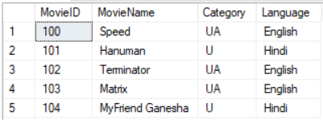

MovieID – Int MovieName-varchar(30) Category- char(2) Language-varchar(25)

SHOWS
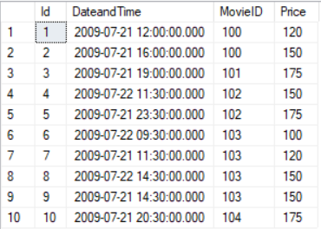

Id -Int | DateandTime-datetime | MovieID-int | Price-int

You need to write the T-SQL commands for the following Questions. For better understanding I have shared you the output.

- Select all movies where language is Hindi.
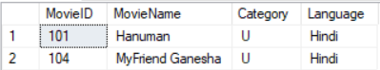

select * from Movies
where Language = 'Hindi'

- Retrieve movieid , name which starts from ‘H’
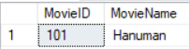

select MovieID,MovieName from Movies
where MovieName like 'H%'

OR

select MovieID,MovieName from Movies
where MovieName like 'H______'

- Select all shows details along with movie details whose languages is 'English'

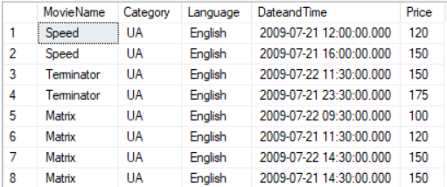

select m.*,s.DateandTime,s.Price
from Movies as m inner join Shows as s
on m.MovieID = s.MovieID
where Language = 'English'

- Select number of shows running per movie. You need to provide movie name along with corresponding number of shows.

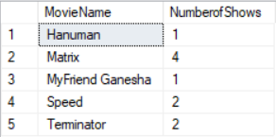

select m.MovieName,count(DateandTime)
from Movies as m inner join Shows as s
on m.MovieID = s.MovieID
group by MovieName

- Show the total price of all shows whose movie name is 'MATRIX'

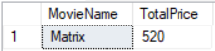

select m.MovieName,SUM(s.Price) TotalPrice
from Movies as m inner join Shows as s
on m.MovieID = s.MovieID
where MovieName = 'Matrix'
group by MovieName

- Show the maximum price of the show whose movie name is 'Terminator'

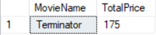

select m.MovieName,MAX(s.Price) TotalPrice
from Movies as m inner join Shows as s
on m.MovieID = s.MovieID
where MovieName = 'Terminator'
group by MovieName

- Show total count of shows on each day for each movie name
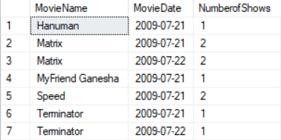

select m.MovieName,cast(s.DateandTime as date) MovieDate,count(s.MovieID)
from Movies as m inner join Shows as s
on m.MovieID = s.MovieID
group by MovieName,cast(s.DateandTime as date)

